VAISHNAVI E 231901059
EXERCISE 13
Detection of real-time threats, analyse recorded traffic files and identify anomalies

Aim: To learn how to use Snort for real-time threat detection, traffic analysis, and anomaly identification using both live and recorded network data.
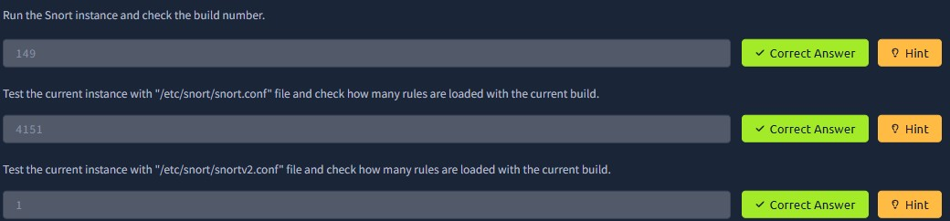
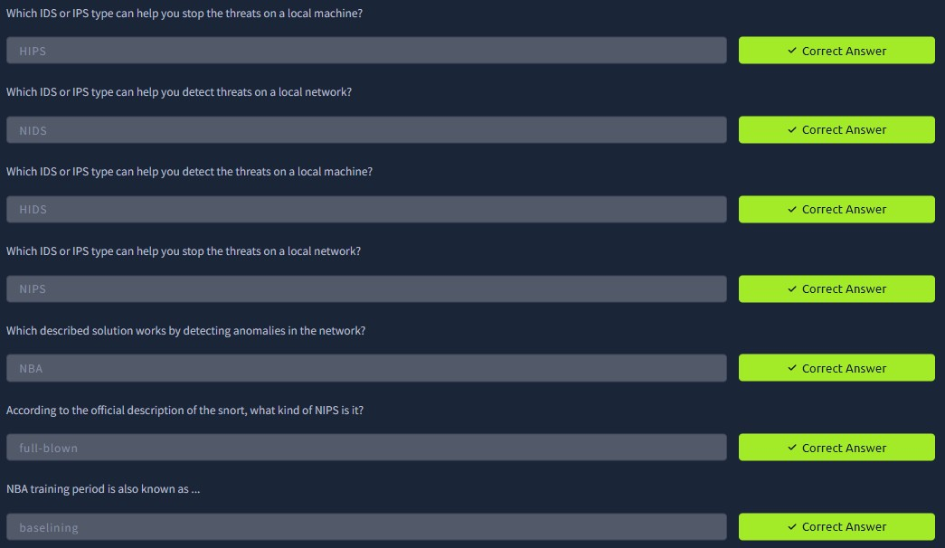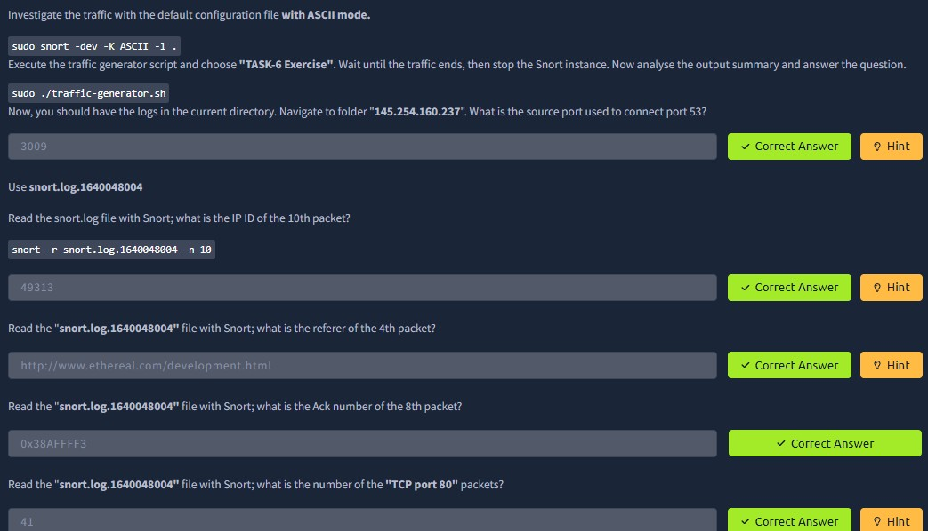
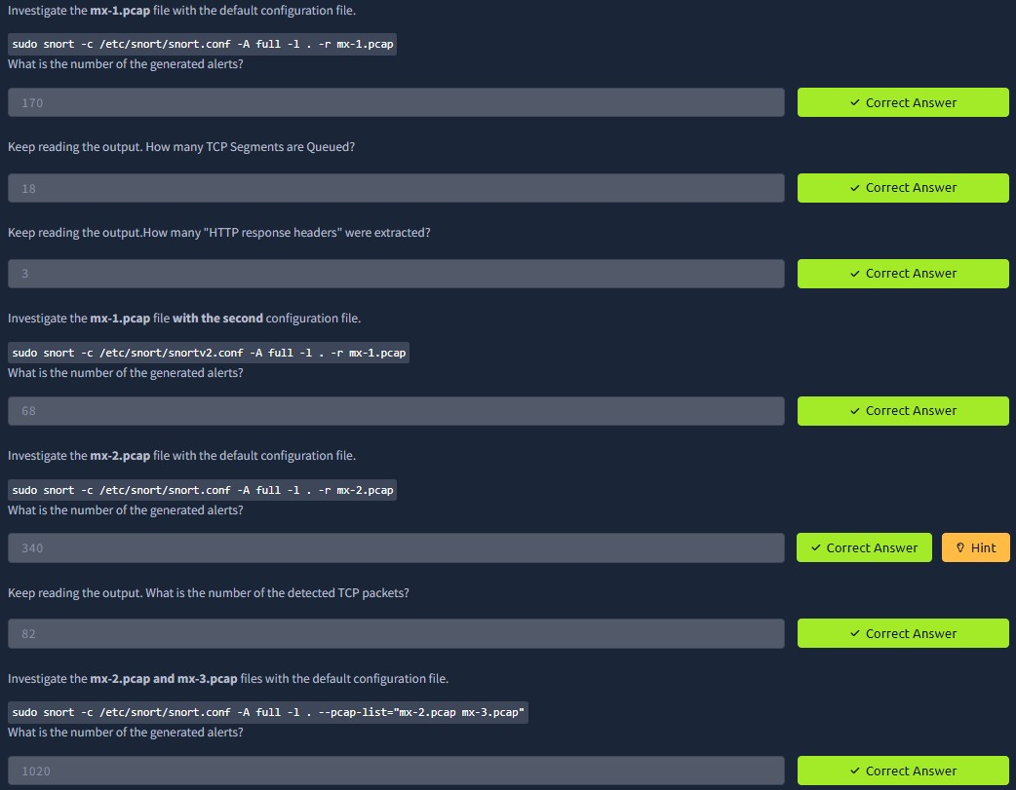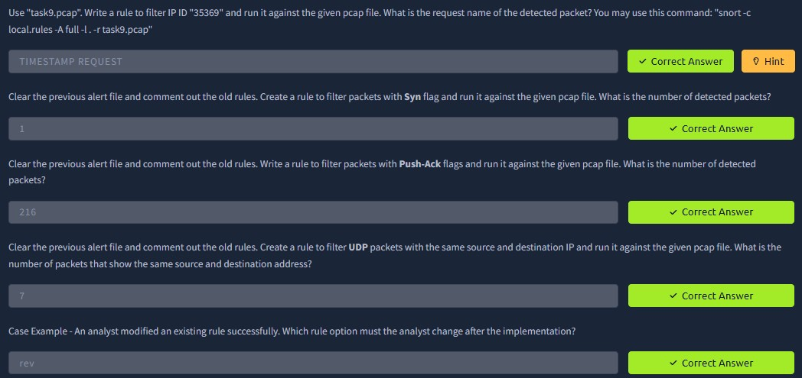

Result: Successfully configured Snort to detect live threats, analyzed pcap traffic files, and identified suspicious patterns and anomalies in network behavior.

